- Write a python script to encrypt the string using Caesar cipher.
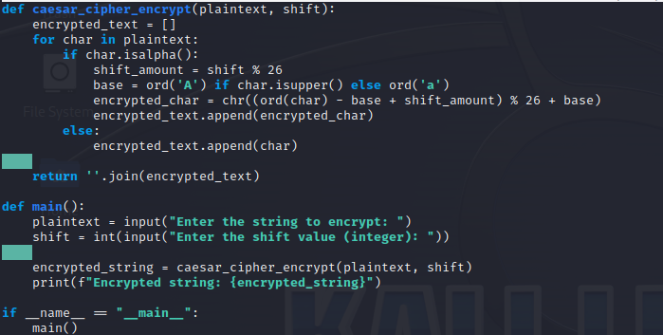
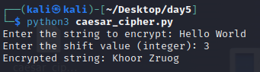
- Write a Python script to Modify the above script to shift cipher based on user choice.
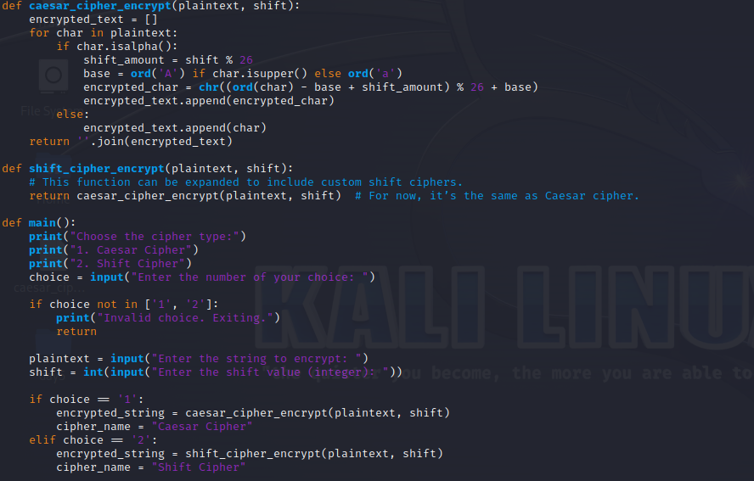
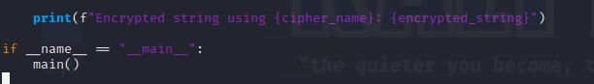
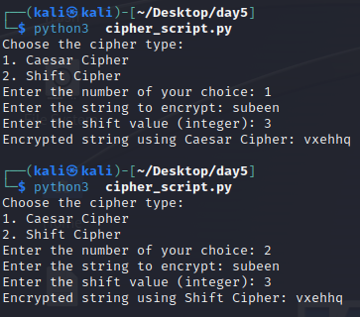
- Write a Python script to convert cipher text into uppercase characters and split the cipher into group of 5 of characters.
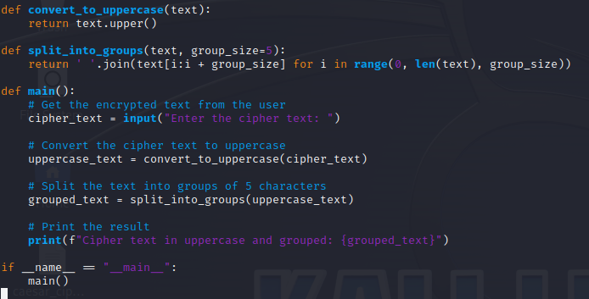
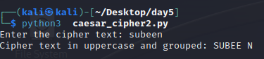
- Write a Python program to Find the histogram for each characters.
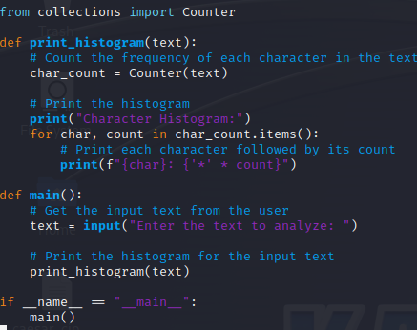
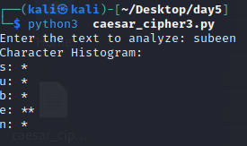

- Write a Python script to read the contents from the file.
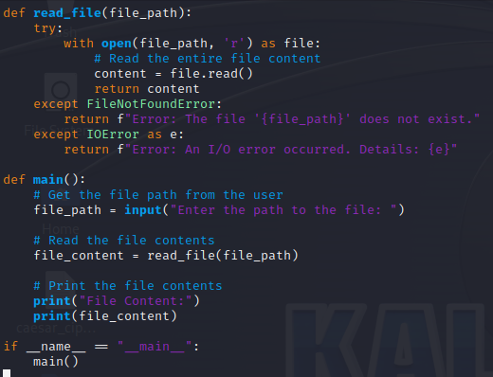
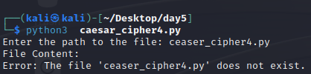

- Write a Python script to encrypt the contents from the file.
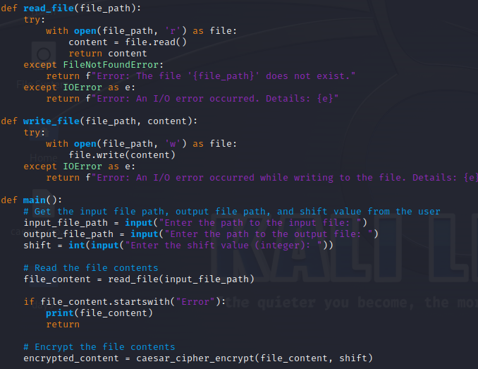
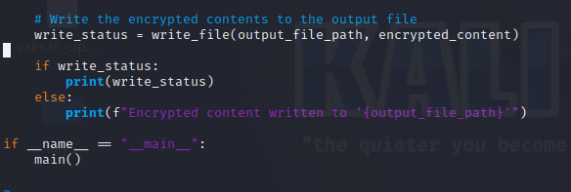
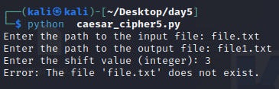
7. Do validation to the python program (2)
- not to accept special characters
- not to accept numeric values
- not to accept empty value
- accept only string
- string should be lowercase if not convert the case
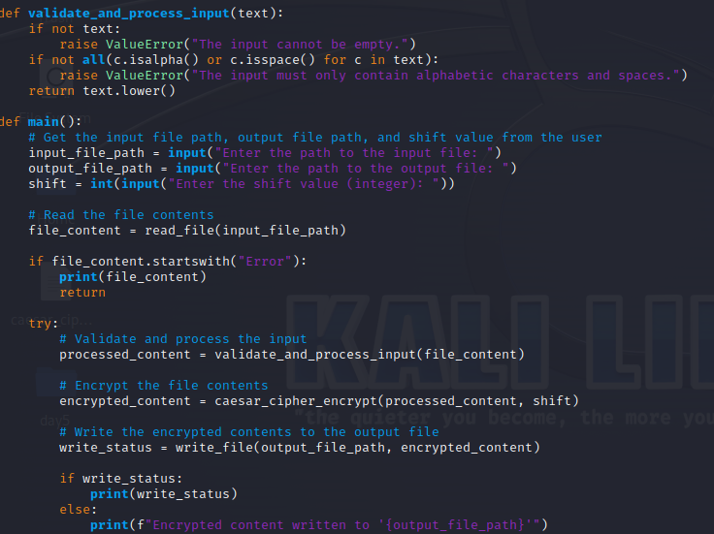
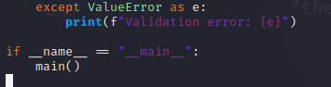
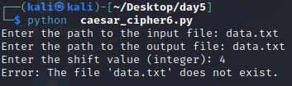
8. Write a Python program to checks if two given strings are anagrams of each other.
example: mug, gum
cork, rock
note, tone
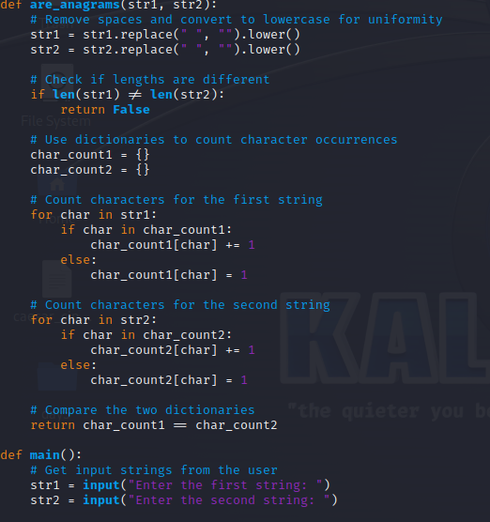
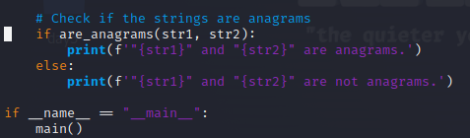
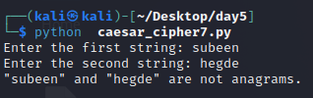
9. Write a Python program to check the given string is palindrome or not
Do not use built in functions

Example: MADAM
RACECAR
LEVEL
CIVIC
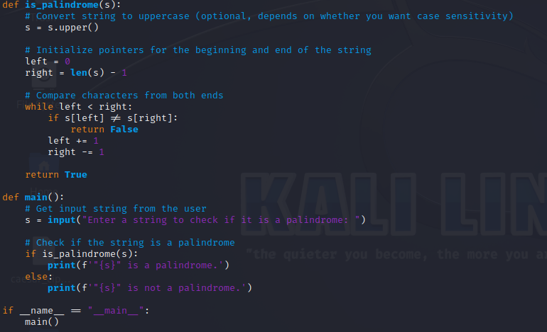
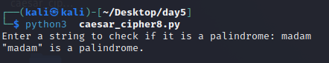

10. Write a Python program to check if a substring is present in a given string.
Example: Understand – stand
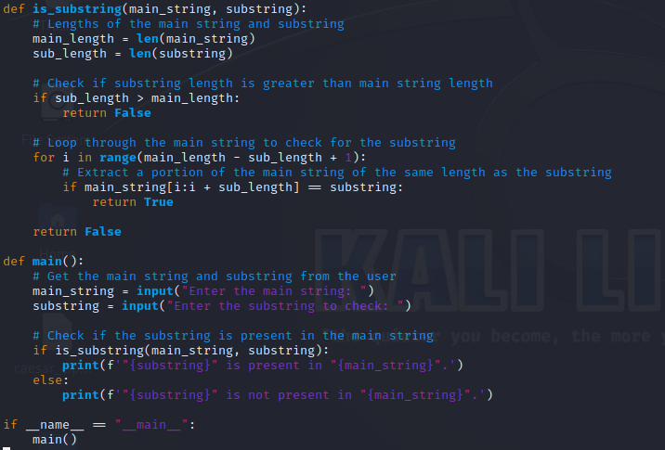
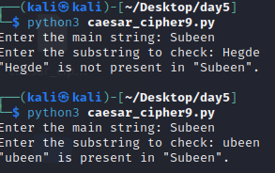

11. Explore string module
import the string module in your python script.
print all the lowercase characters
print all the uppercase characters
print all the lowercase and uppercase characters
print all the digits
print all the punctuation symbols
count the total number of punctuation symbols
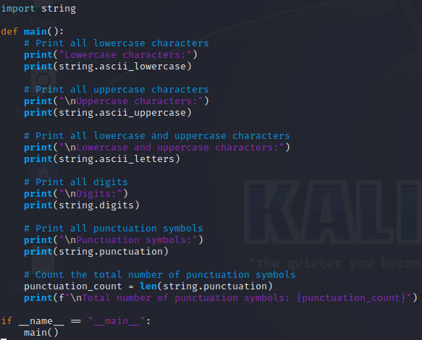
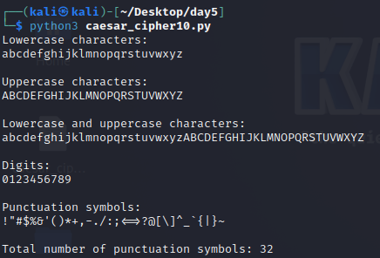
Programming is a skill best acquired by practice and example rather than from books -- unknown

The only way to do great work is to love what you do --Steve Jobs

